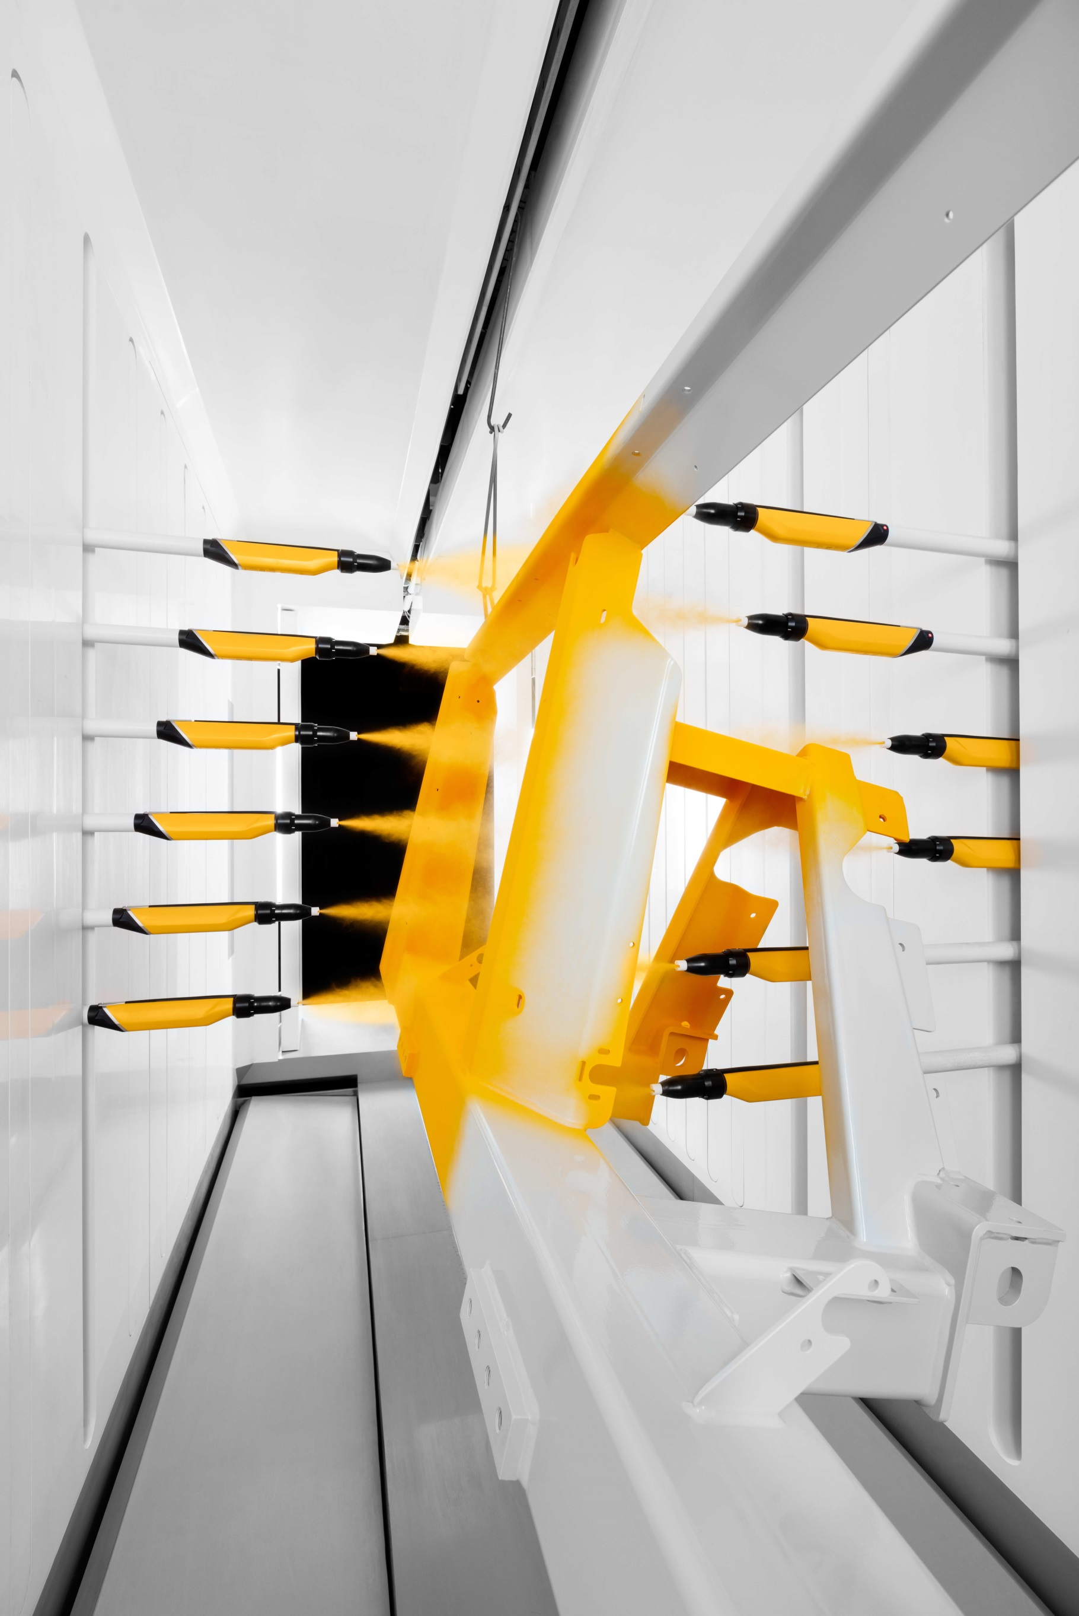
QUOTATION

Sonalika Industries

Hosiarpur , Punjab

Mr. Swarnendu Kale
+917508029197

Quotation Details
Quotation number: GIN-23-01284-OF-R0
Quotation date: 27th-October-2023

Our Contact Reference
Harish Sharma +91 9811846214 harish@optifinish.in

The Gema Group
Pioneer in electrostatic powder coating
Gema is a company with a long history. Founded in Switzerland in 1897 by Messrs. Gehrig and Mannhart (hence the origin of the name) Gema started as metal fabricator and later specialized in metal ceilings.
In the 1960’ years Gema started to experiment with the idea - at that time revolutionary - of electrostatic powder coating and produced the very first powder gun on the market. Although initially developed for its own use, the technology was so interesting and efficient that it was decided to start selling powder guns: the Gema electrostatic division was born!
Gema became a stand-alone company in 1982 with the spin-off of the electrostatic division.
Since 2012 Gema is part of Graco (www.graco.com), an internationally leading supplier of management solutions for fluids and coatings in both industrial and commercial applications. Part of our division are also SAT (www.sataluminium.com), market leader in vertical finishing systems for aluminum extrusions, and Hildebrand Technology (www.hildebrand-technology.com), our experts in static control solutions.
Always one step ahead
After starting first, Gema has kept its leadership position in powder coating for more than 50 years thanks to a strong focus on R&D and creativity. Over the years Gema launched so many famous innovations and unique designs, like the first gun with integrated high voltage generator, the MFR filter-belt booth, the Magic Cylinder round booth design, the SuperCorona free ions collector, the first OptiSelect manual gun with integrated remote control, the MagicCenter powder kitchen with automated color change, the EquiFlow booth airflow design, the Smart-Inline-Technology of our dense phase pumps, the contour detection laser scanner for automatic application, the new All-In-One gun control units…
Today Gema can count on the largest patents portfolio in the market and offers a broad variety of products and solutions, from manual coatings to the most sophisticated industry 4.0 automations.
A strong worldwide presence
Gema’s worldwide headquarters are in St. Gallen, Switzerland; here our team works every day to develop our newest technologies and to make sure that our products are manufactured in perfect quality and punctually delivered everywhere in the world.
Our distribution network includes a combination of Gema business units and independent distributors in more than 60 countries worldwide, offering sales and service support to maintain the Gema equipment in perfect shape for many years after the first installation.
Application experts in every market
Architectural elements, home appliances, automotive components, metallic furniture… everywhere the most famous brands rely on our expertise for their powder coating projects.
Our state-of-the-art coating laboratories are available in Europe, America and Asia for the most complex coating trials. Here our customers can test our advanced technologies and determine the most effective equipment configuration to achieve the best application quality.

Technical Description

Project Specifications

Work piece data:
Type of Object: Farm Equipment
Max Height NA

Production data:
speed of Conveyor: NA

Application data:
Powder Type: Organic Powder

The design of this solution is based on the experience we have gained from several successful projects with similar technical specifications.

Technical Description

Scope of Supply

Automatic Application Equipment
1 OptiFlex AS10 electrical cabinet (Manufactured Locally)
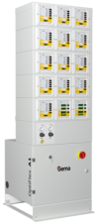
- Freestanding IP54 protected base cabinet, equipped with pneumatic unit, including air filter/regulator and air connection sockets for control units
- Modular upper structure designed to accommodate Gema master control , gun controls, reciprocator controls, powder hopper controls
- Power supply
Standard: 3x400 VAC+N+PE / 50/60Hz
US Market: 100-120 V 60Hz

Technical data:
Width: 600 [mm]
Depth (incl. base): 300 (550) [mm]
Max height: 1'880 [mm]
12 OptiStar 4.0 CG20 gun control

The new benchmark for gun controls
- 3 pre-set standard application programs and 250 user definable application programs - easy operation for beginners / powerful functions for the experts
- PCC technology to optimize the electrostatic charging even for challenging powders
- DVC technology grants the most precise and repeatable powder output settings
- Powder output calibration function, allowing for identical powder output at identical settings for all guns of a powder coating line, irrespective of their individual powder hose length
- Adjustment function to temporally change the powder output, without modifying the selected application program
- Wear part monitoring by working hours counters for the main wear parts
- Bluetooth connectivity to Gema E-App allowing device setup, application parameter adjustments and line data monitoring via mobile device
- Key pad lock to prevent unintended user input
- Diagnostics module and error code indication for easy trouble shooting
- Rinsing mode to remove powder accumulations from the injector, powder hose and gun

8 OptiGun GA03 automatic gun
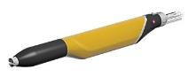
More powder on the parts - less in the recovery
- Based on Gema corona charging technology
- Integrated 100 kV high power cascade for unmatched first pass transfer efficiency
- Equipped with high efficiency nozzle, ensuring highest quality application results
- Wide selection of special nozzles available as option
- Robust design, optimized for fast & reliable color change as well as low & easy maintenance
- Designed for use of organic and metallic powders
4 OptiSelect GM04 manual gun
The manual gun for maximum coating performance

- Based on Gema corona charging technology
- Integrated 110 kV PowerBoost technology based cascade for unmatched first pass transfer efficiency
- Equipped with high efficiency nozzle, ensuring highest quality application results
- Wide selection of special nozzles available as option
- On-gun remote control to adjust all coating parameters
- Robust design, light weight and very ergonomic design
- Optimized for fast & reliable color change as well as low & easy maintenance
- Designed for use of organic and metallic powders
12 OptiFlow IG07 injector
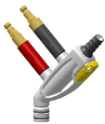
The first choice in injector technology for high performance powder conveying
- Single-component Inline Cartridge Design and 135° open angle design reduces wear consumption, guarantees a long term consistent powder flow and enables even faster wear part exchange
- Designed to work with Gema DVC Technology
- All connections equipped with quick release couplings - Plug & Convey
- Robust die-cast housing
- Designed for mounting on fluidized powder hopper, includes suction tube
1 HF100 powder hopper (Manufactured Locally)
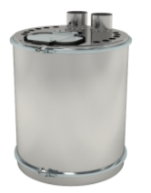
- High quality fluidized bed, designed to accommodate up to 12 injectors
- Opening for automatic powder supply and opening with lid for manual powder supply and inspection
- Easy to clean Mild steel construction
- Opening to accommodate level probe
- Air mover

Technical data:
Diameter 24 mm
Height 600 mm
Capacity 100 l

2 HF30 powder hopper (Manufactured Locally)

- High quality fluidized bed, designed to accommodate 1 injector
- Easy to clean Mild steel construction
- Air mover

Technical data:
Diameter 300 mm
Height 300 mm
Capacity 30 L

1 Caster for HF powder hoppers

1 OptiAir CA12 powder hopper control
Ideal for optimal powder conditioning
- Manual pressure regulators and pressure gauges for fluidizing and air mover
- Manual pre- fluidizing function to "loosen up" compacted powder
8 Gun supports

Packing, Freight, Insurance
Delivery FOR at your works Hosiarpur
- Including packaging, freight and insurance.

Installation and Training
Start-up and training with a specialized Gema engineer

Commercial Conditions

Price Summary

Automatic Application Equipment
1 OptiFlex AS10 electrical cabinet (Manufactured Locally)
12 OptiStar 4.0 CG20 gun control
8 OptiGun GA03 automatic gun
4 OptiSelect GM04 manual gun
12 OptiFlow IG07 injector
02 HF-30 Powder Hopper(Manufactured Locally)
1 HF100 powder hopper (Manufactured Locally)
1 OptiAir CA12 powder hopper control

Packing, Freight, Insurance
Delivery at Hosiarpur

Installation and Training
Start-up and training with a specialized Gema engineer

GRAND TOTAL PROJECT(Basic) Rs.38,00,000

GST EXTRA@18% further added on to it.

Technical Attachments

Main Technologies
Click the image to download the PDF document
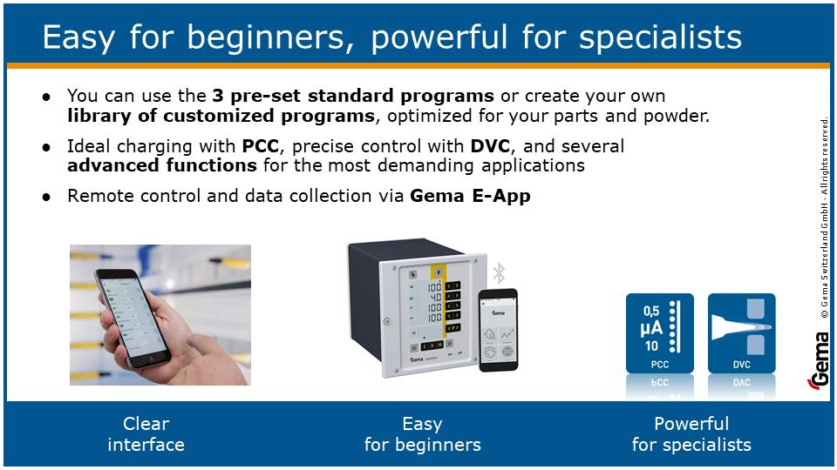

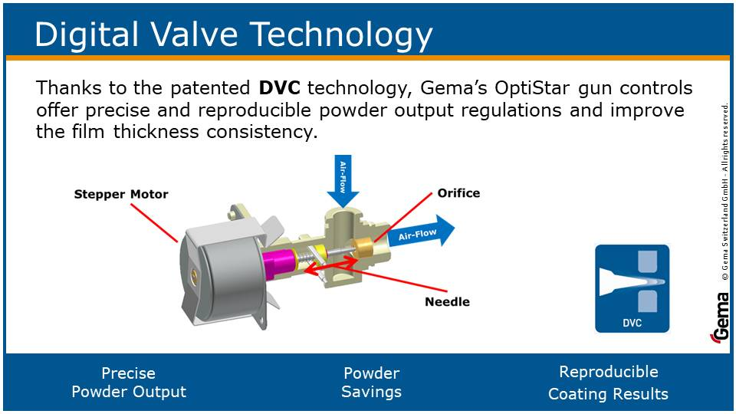

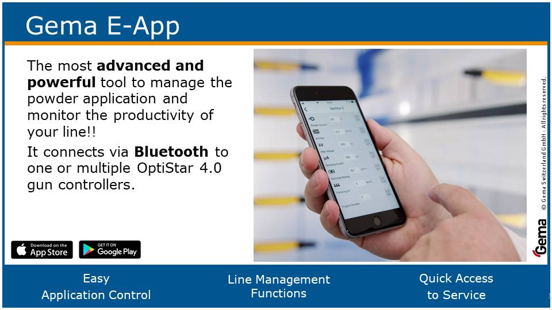

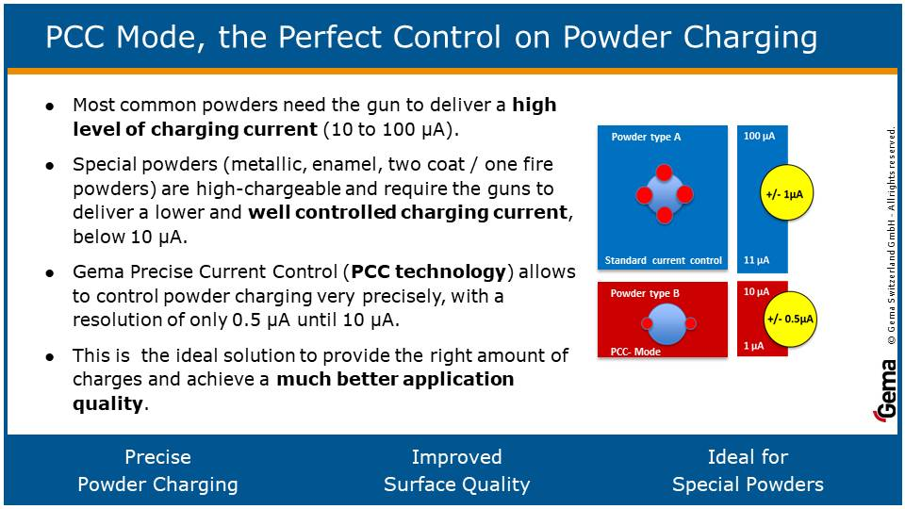



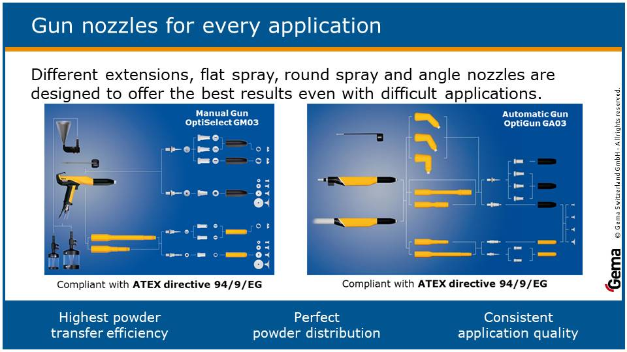



Technical Attachments

Connections and Energy Consumption

Compressed air connection data:
Max input pressure 10 [bar]
Min input pressure 6 [bar]
Max permissible water vapor content 1.3 [g/Nm³]
Max permissible oil vapor content 0.1 [mg/Nm³]
Max air consumption - operation 150 [Nm3/h]
Normal air consumption - operation 120 [Nm3/h]

Electrical connection data:
Single phase voltage 230 [V]
Frequency 50/60 [Hz]
Voltage tolerance ± 10 [%]
Type of protection class IP54
Max power consumption 5 [kVA]
Normal power consumption 3 [kVA]
Please consider the heat generated by the equipment for the thermal balance of the environment!

Sales Conditions

Payment Conditions
50% on receipt of order
50% on delivery readiness against Pro-Forma Invoice

Deliver Conditions
FOR Hosiarpur

Warranty
12 months, one shift (8 hours) per day, beginning after commissioning.
There will be no warranty if other than original Gema spare parts are used.

Exclusions
The following items are excluded from our scope of supply, unless they are specifically mentioned:
- Building work and laying foundations on site and the necessary drawings
- Ventilation / air conditioning of the plant
- Supply and installation of main lines and sources, electrical power and compressed air to the -equipment including the required switches, valves, fuses, etc., according to our instruction
- Installation materials for the connections to all driven units
- All pressure release flaps and ducts to the exterior
- Equipotential line, including laying up to the equipotential bar acc. VDE 0141; Cross-section min. 16 [mm2]
- Suspensions for the conveyor within the area of the coating plant
- M6 or M10 connectivity for Gema encoder on conveyor
- Platforms for the manual touch-up openings
- Safety fences
- Erection aids and tools incl. necessary scaffolding
- Unloading, transport inside factory, and placing of plant items on erection site
- Disposal of waste materials (packaging, etc.)
- Powder for plant commissioning
- Packing, shipping, installation and commissioning
- Any items not especially mentioned in this offer

General Sales Conditions
1. Preamble
These general conditions of sale of Gema Switzerland GmbH (“Our Company” in the rest of this document) apply to the entire product range of our products and are an integral part of all sales contracts concluded with our customers. They also apply to future transactions even if these do not explicitly reference these general conditions of sale. With the conclusion of the sales contract, at the latest, the customer accepts these general conditions of sale. Customer orders become binding only when they are confirmed in writing by Our Company, or when the ordered goods are shipped. Our Company reserves the right to reject any orders without disclosing the rea-sons.
2. Technical specifications and documents
Technical documents such as drawings, descriptions, illustrations as well as any dimension, performance or weight specifications are strictly for information purposes and do not warrant specific characteristics. Our Company reserves the right to make changes as technical progress may warrant. All technical documents remain the intellectual property of Our Company and may only be used for the purposes specified by or agreed to by Our Company. The images included in this document are for illustration purpose only and may differ from the actual products. The text and images included in the section “Main Technologies” are for explanation purpose only and do not constitute a guarantee of the performance of the products. Materials, specifications, details and dimensions are approximate and subject to change without notice and without any liability being incurred by Our Company.
3. Regulations applicable at the place of destination
With the order, at the latest, the purchaser shall supply Our Company with information on the regulations and standards applicable at the place of destination to the extent that these are relevant to the supply of goods and services as well as to the conformance with safety and approval regulations. In the absence of any other stipulations the supplied goods and services shall conform to the regulations and standards applicable at the domicile of the purchaser as specified by the latter to Our Company.
4. Prices
Save for any stipulations to the contrary, all prices are deemed to be net, f.o.b. our address, excluding packing, and without any deductions. All extra costs such as freight, insurance, permits for export, transit, import etc., as well as any certificates, shall be borne by the purchaser. The purchaser is also responsible for any taxes, fees, and custom duties imposed on the delivery. If the costs for packing, freight, insurance, taxes, duties and other extra costs are included in the offer or delivery prices, or if they are itemized separately in the offer or on the order confirmation, then Our Company reserves the right to adapt the rates to any changes in the tariffs.
5. Terms of payment
The purchaser shall tender payment at the domicile of Our Company without any deductions such as discounts, expenses, taxes, and fees, in accordance with the agreed terms of payment. In the event of late payment by the purchaser, default interest at the then prevailing Euromarket interest rate, but not less than 6% p.a., will be charged. If the purchaser defaults on his payments, Our Company reserves the right to hold back deliveries relating to other orders or to cancel such orders. Our Company reserves the right to execute deliveries on C.O.D. basis for as long as the purchaser defaults on his payments or if requests for payment had to be issued for previous orders. If after the placement of an order the purchaser becomes insolvent or if he suspends payment to Our Company, or if the purchaser's ability to pay is impaired in any other way, Our Company has the right to request adequate security and if none is pledged, Our Company may rescind the contract. The purchaser is neither entitled to make partial payments, nor to make offsets with counterclaims, nor to withhold payment due to any complaints. In particular payment shall also be made if only insignificant parts of the delivery are missing which do not render utilization impossible.
6. Reservation of ownership
All goods remain the property of Our Company until Our Company has received full payment from the purchaser in accordance with the contract. The purchaser shall participate in all measures and execute all documents that are deemed necessary for protecting Our Company's ownership of the goods. With the signing of the contract the purchaser consents that the reservation of ownership may be recorded, at his own expense, in public registers, books, or the like in accordance with the applicable national laws, and to sign any documents required for this purpose. While the reservation of ownership is in force, the purchaser shall, at his own expense, maintain the supplied goods in proper order and insure them against theft, breakage, fire, water and other risks, with Our Company designated as the beneficiary. In addition the purchaser shall take all necessary steps to prevent the impairment or nullification of Our Company's ownership rights. If the purchaser sells goods of which the ownership has been reserved by Our Company, the purchaser cedes already now to Our Company in an internal relationship all rights against the buyer accruing to him from this sale, including all ancillary rights, securities and reservation of ownership. If the value of the goods over which ownership has been reserved, together with any other securities granted to Our Company exceed the claims of Our Company against the purchaser by more than 20%, then Our Company shall grant a partial release if this is demanded by the purchaser. If the purchaser takes any action that contravenes the contract, particularly if he defaults on his payments, Our Company is entitled, after having given notice, to take back the goods over which it holds reserved ownership and the purchaser is obligated to release the goods.
7. Delivery
The scope and the execution of the supply of goods and services shall be governed by the order confirmation. Whenever possible, Our Company will deliver the entire order of the customer. However, the purchaser agrees, to accept also partial deliveries. For partial deliveries Our Company is entitled to issue corresponding partial invoices. The delivery period begins when the contract has been signed, when all government formalities such as import and payment authorizations have been obtained, the payments or securities to be delivered together with the order have been received, and all technical specifications have been clarified. Delivery is deemed to have been made on schedule if on expiration of the delivery period the goods are ready for shipment and a corresponding advice has been forwarded to the purchaser. The delivery period shall be reasonably extended if:
a) The information required by Our Company for executing the order is not received on time or if it is subsequently modified by the purchaser and thus causes a delivery delay;
b) If Our Company is impeded by force majeure from executing the order. The term force majeure comprises all unforeseeable circumstances for which Our Company is not answerable and which make it unacceptably difficult or impossible for Our Company to execute the delivery, such as delayed or faulty deliveries by its subcontractors, strike, government regulations, shortage of raw materials or energy, major interruption of operations caused, for example, by the complete or partial destruction of the plant or important departments, or by the breakdown of essential production equipment, serious transport problems, for example, caused by road blockage. If these conditions persist for more than six months, either party has the right to rescind the contract. However, the purchaser is not entitled to raise any claim for damage;
c) If the purchaser or third parties are in arrears with their work to be performed or the fulfillment of their contractual obligations, particularly if the purchaser fails to meet the payment terms.
If the delivery period is exceeded for reasons that depend from Our Company, the purchaser shall, through written notification, grant a reasonable extension which shall be at least one month. If delivery is not made within this extension period, the purchaser may rescind the contract. However, the purchaser is not entitled to raise any damage claim unless malicious intent or gross negligence on part of Our Company can be demonstrated.
If the goods notified as being ready for shipment are not accepted on time by the purchaser, Our Company is entitled to store the goods at the expense and risk of the purchaser and to invoice them as being delivered.
8. Passing of use and risk
The use and risk pass to the purchaser as soon as the shipment has left Our Company’s plant, even if the delivery is made c.i.f. or under similar clauses, or including installation, or if the transport has been organized and managed by Our Company. If shipment is delayed due to circumstances for which Our Company is not answerable, the risk passes to the purchaser as soon as he has been advised that the goods are ready for shipment. From this moment the goods are stored and insured at the expense and risk of the purchaser.
9. Transport and insurance
In the absence of any stipulations to the contrary the goods are shipped at the expense and risk of the purchaser. Insurance against damage in transit shall be arranged by the purchaser. Even if this insurance is arranged by Our Company it is deemed to have been concluded on behalf and on the account and risk of the purchaser. Special requests concerning shipment and insurance shall be communicated to Our Company on time. Otherwise the fastest and most economical transport will be arranged at the discretion of, but without responsibility, by Our Company. For c.i.f. deliveries the transport is arranged by Our Company. If any special requests are made by the purchaser the additional costs will be charged to him. If any goods are lost or damaged in transit, the purchaser shall enter a corresponding exception on the delivery documents and have the damage immediately surveyed by the forwarding company. Transport damages that were not immediately detectable must be reported to the forwarding company within eight days from the delivery of the goods.
10. Inspection and acceptance of the supplied goods and services
Our Company inspects all goods during production within the normal scope. If the purchaser requires additional tests and inspections, these shall be agreed upon in writing and will be conducted at the expense of the buyer. The purchaser shall examine the delivery within a reasonable time and report any defects to Our Company immediately in writing after they have been detected, however, within the agreed warranty period. In the absence of any written complaint the delivery is deemed to have been accepted.
11. Warranty
On written request by the purchaser Our Company shall, at its own discretion, either repair or replace as quickly as possible such parts of the delivered products that evidently became damaged or unusable due to poor workmanship, or incorrect operating instructions or installation instructions. The replaced parts become the property of Our Company. The purchaser is entitled to rescind the contract or demand a price reduction if
a) Repair or replacement is impossible;
b) Our Company is unable to remedy the defect within a reasonable time, or if Our Company refuses or culpably delays remedy of the defect.
For products that have been manufactured based on the specifications, drawings or models supplied by the purchaser, Our Company's warranty is limited to the quality and workmanship of the materials. Not covered by the warranty are damages that are not clearly the result of poor material, design errors, poor workmanship or incorrect operating instructions and installation instructions, for example, due to normal wear, improper storage and maintenance, failure to follow the operating instructions, overloading, utilization of media that do not meet specifications, inexpert interventions by the user or third parties, utilization of spare parts not authorized by Our Company, as well as due to other reasons for which Our Company is not answerable. For major third party deliveries Our Company grants a warranty only within the scope of the original supplier. Warranty and liability claims become statute barred twelve months from the receipt of the goods by the purchaser, but no later than 18 months from the date the goods left the Our Company’s plant. With respect to defects in materials, design or workmanship [as well as characteristics that do not conform to the specifications], the purchaser has no rights or remedies other than those explicitly stipulated in the section “Warranty”. For claims of the purchaser that relate to inadequate counselling and the like, or to the violation of any ancillary obligations, the supplier is only liable if he acted unlawfully or with gross negligence.
12. Liability (Exclusion of damages)
Our Company 's liability to pay damages of any kind is waived to the extent that this is permitted by the applicable law. This applies in particular to damages for delays, consequential damages, and product liability damages of all types.
13. Concluding provisions
Our Company does not recognize any terms of business other than these. The purchaser explicitly waives the right to invoke his own conditions.
The acceptance of an order by Our Company does not imply that the customer's terms of business are accepted, not even if this is mentioned on the order form. If any part of these general conditions of sale or any delivery executed thereunder is deemed to be invalid, this shall in no way impair the validity of the other terms and conditions. Changes to these general conditions of sale are only valid if they have been accepted by Our Company in writing.
All contracts with Our Company are subject to the laws of Switzerland. Any legal disputes arising out of or in conjunction with contracts between Our Company and the purchaser to which these general conditions of sale are applicable, shall be brought before a competent court at the domicile of Our Company. In any action against the purchaser Our Company reserves the right to institute legal proceedings at the domicile of the purchaser.

